The TreeMap Class
(from the Java Collections Framework)

import java.util.*;

public class JCFTreeMap
{
public static void main(String[] args)
{
TreeMap persons = new TreeMap();

persons.put(new Integer(888888888), "Taylor, Fritz");
persons.put(new Integer(222222222), "Johnson, Alan");
persons.put(new Integer(123456789), "Bleaux, Joe");
persons.put(new Integer(999999999), "Johnson, Alan");
persons.put(new Integer(123456789), "Rogers, Tiffany");
persons.put(new Integer(555555555), "Nguyen, Viet");
persons.put(new Integer(666666666), "Jones, Adam");

System.out.println(persons.containsKey(new Integer(888888888)));
System.out.println(persons.containsValue("Rogers, Tiffany"));
System.out.println("***********************");

Iterator itr = persons.entrySet().iterator();
while (itr.hasNext())
System.out.println(itr.next());

System.out.println("***********************");

itr = persons.values().iterator();
while (itr.hasNext())
System.out.println(itr.next());
}
}

Sample Run
true
true

***********************
123456789=Rogers, Tiffany
222222222=Johnson, Alan
555555555=Nguyen, Viet
666666666=Jones, Adam
888888888=Taylor, Fritz
999999999=Johnson, Alan
***********************
Rogers, Tiffany
Johnson, Alan
Nguyen, Viet
Jones, Adam
Taylor, Fritz
Johnson, Alan
The TreeSet Class
(from the Java Collections Framework)

TreeSet myTree = new TreeSet();
myTree.add ("C");
myTree.add ("O");
myTree.add ("N");
myTree.add ("G");
myTree.add ("R");
myTree.add ("A");
myTree.add ("T");
myTree.add ("U");
myTree.add ("L");
myTree.add ("A");
myTree.add ("T");
myTree.add ("I");
myTree.add ("O");
myTree.add ("N");
myTree.add ("S");
myTree.remove ("C");
Iterator itr1 = myTree.iterator( );
itr1.next( );
itr1.next( );
itr1.next( );
System.out.println (itr1.next( ));
itr1.remove( );
itr1.next( );
System.out.println (itr1.next( ));
System.out.println("****************");
Iterator itr2 = myTree.iterator( );
while (itr2.hasNext())
System.out.println(itr2.next());

Sample Run
L
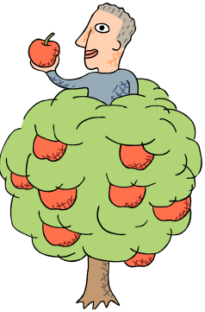
O
****************
A
G
I
N
O
R
S
T
U

